**Python Installation guide:**

1. Go to Link: <https://www.python.org/getit/>

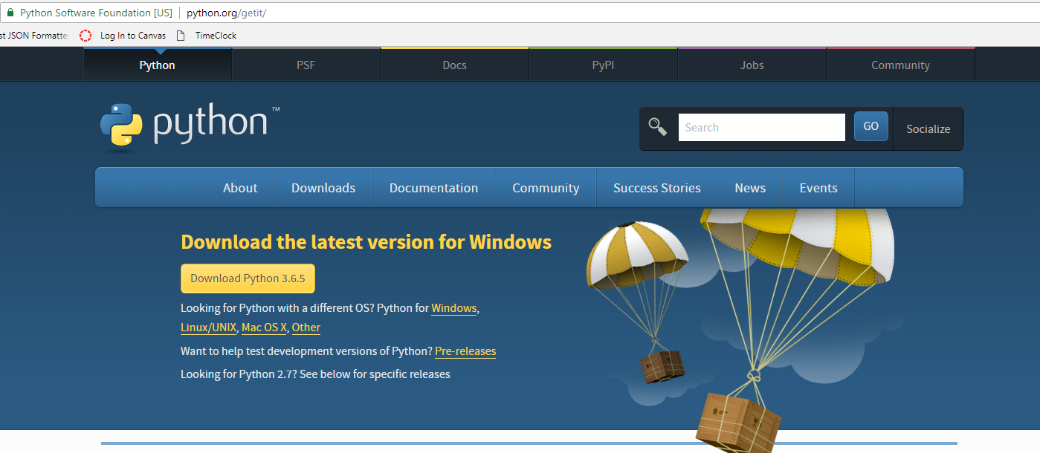

1. Click on the Download the Python 3.6.5 button.
2. A file starts downloading.
3. Open the downloaded file
4. Mark Add python 3.6 to PATH option and click on **Install now**

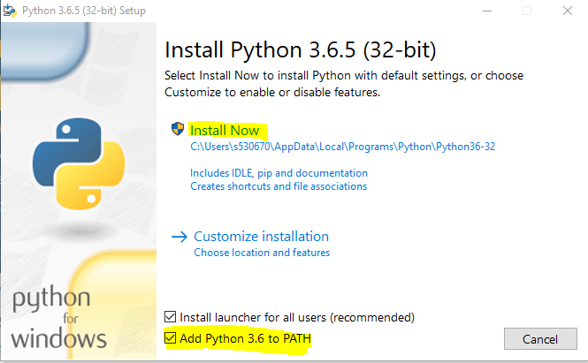

1. After successful installation you will see below screen

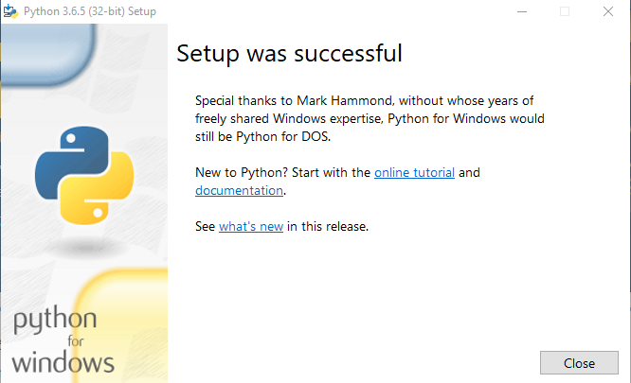

1. Open GitBash terminal or Command prompt anywhere on desktop and check the version by entering command **python –version**

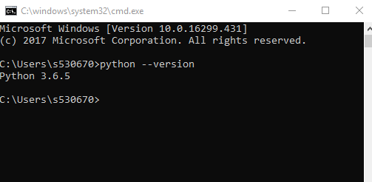

**NodeJS Installation guide:**

1. Go to Link: <https://nodejs.org/en/download/>

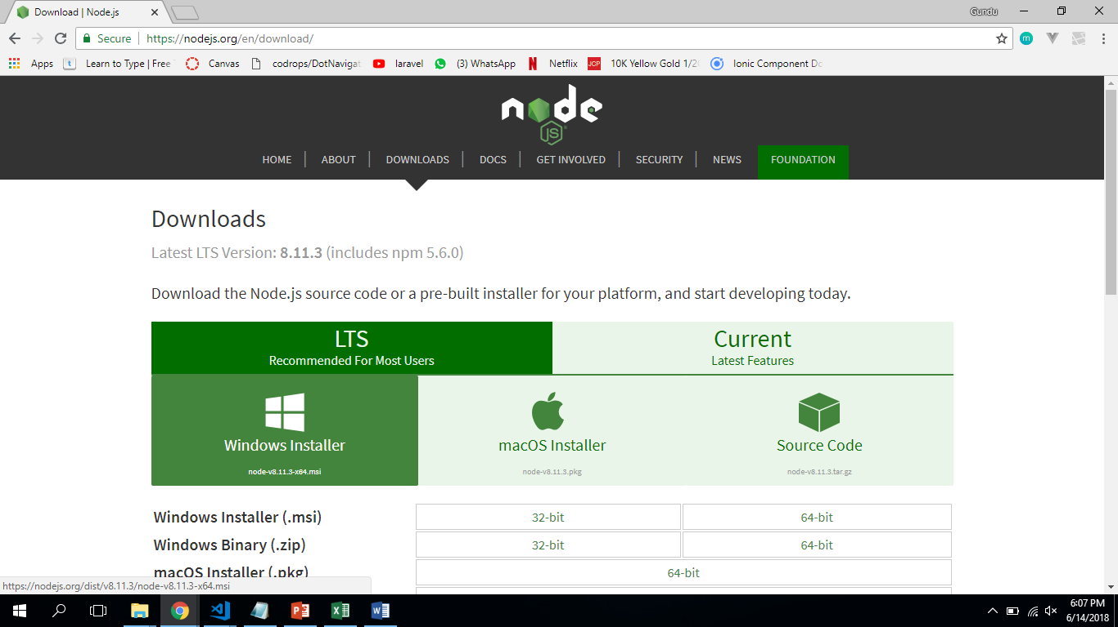

1. Select Windows Installer and you will be able to notice a file starts downloading.
2. Open and setup the downloaded file.

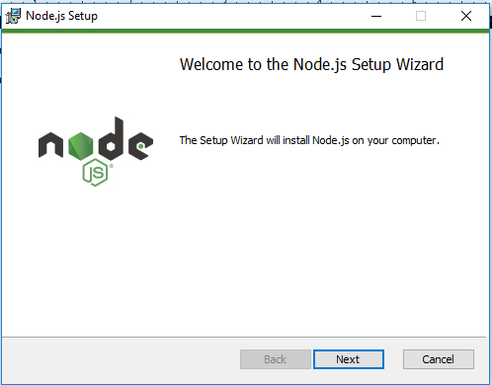

1. Proceed till you install the NodeJS

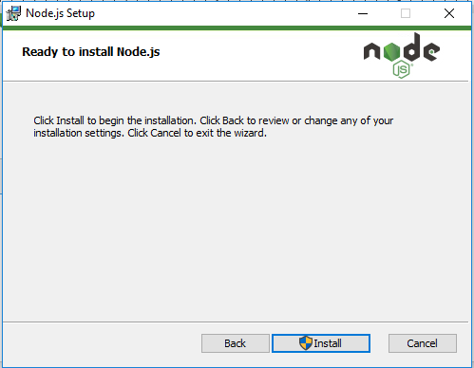

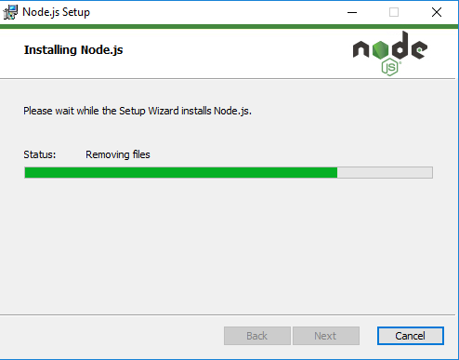

1. After setting up the NodeJS you will be able to see the below screen

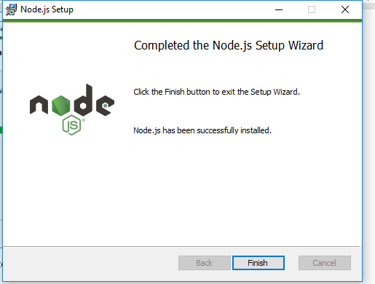

1. Open GitBash terminal or Command prompt anywhere on desktop and check the version by entering command $node -v

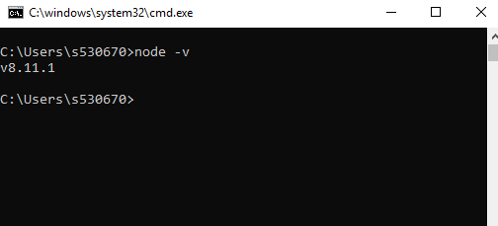

**Twitter Developer Account Setup:**

1. Go to Link: <https://apps.twitter.com> and click on sign in. (If you don’t have twitter account, please sign up for it).

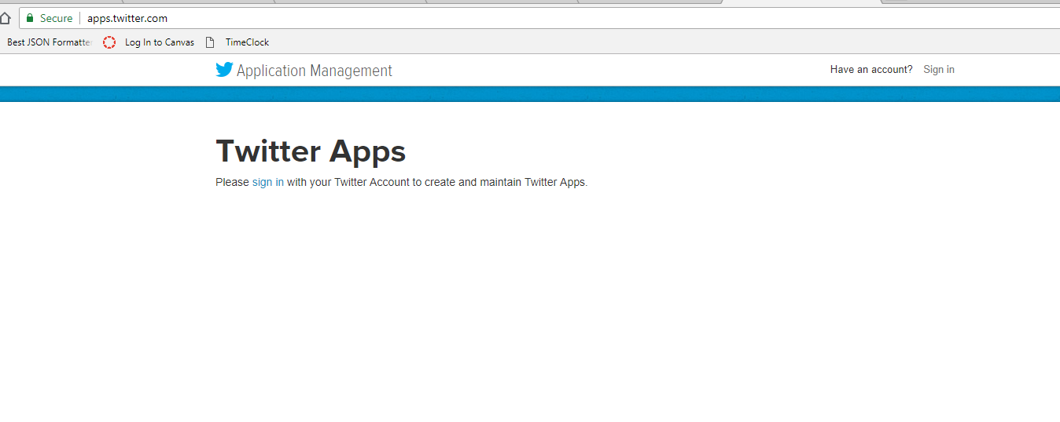

1. Sign in with your Twitter account

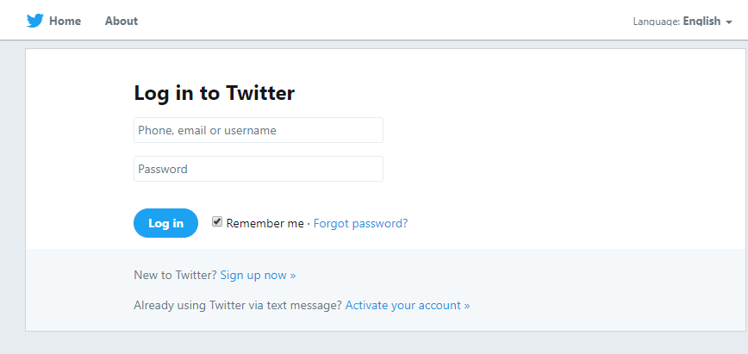

1. Click on **Create New App**

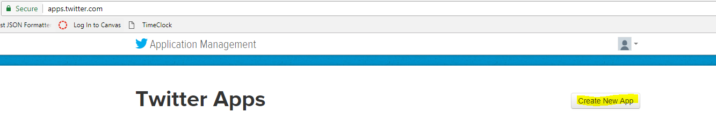

1. Fill in application details

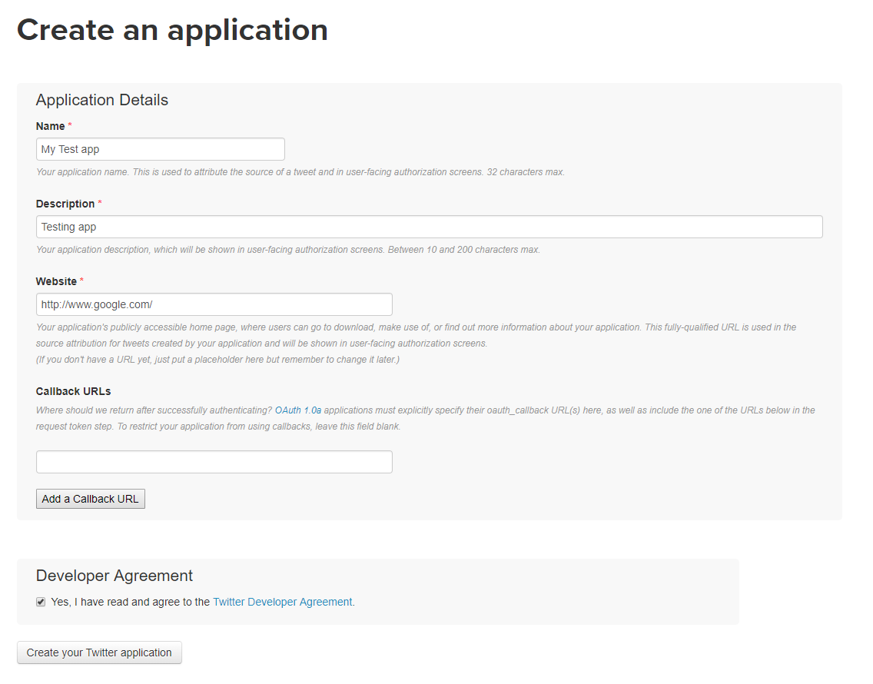

1. You can able to see the app details as shown below

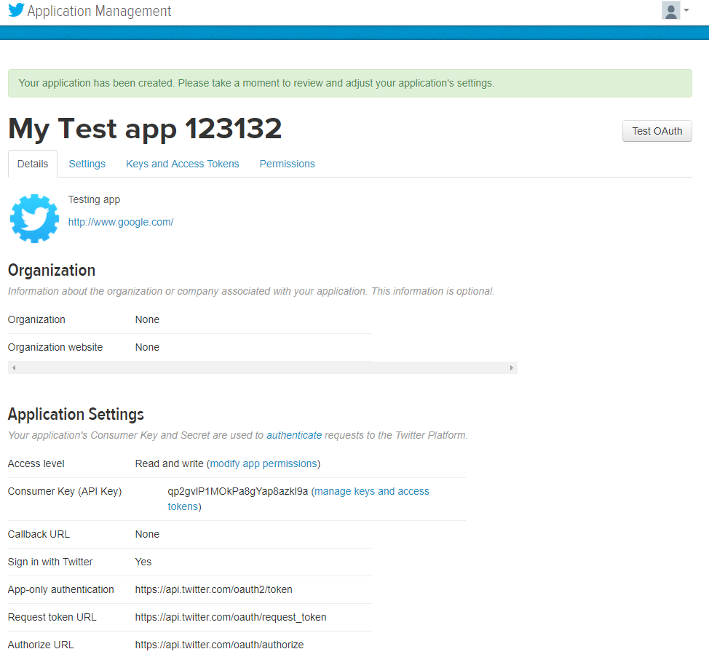

1. Go to **Keys and Access Tokens** Tab
2. Look for **Create and my access token** button and click on it

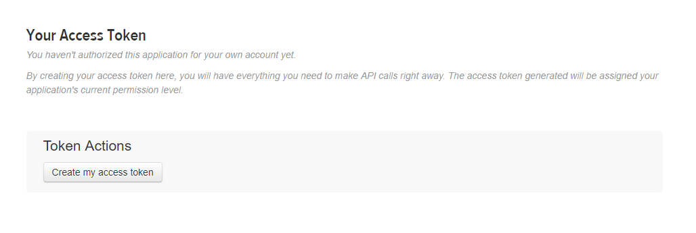

1. Make a note of OAuth Settings
   * Consumer Key
   * Consumer Secret
   * OAuth Access Token
   * OAuth Access Token Secret